Data Prediction Using Deep Learning

A Project Work
submitted in partial fulfillment of the
requirements for the degree of

Bachelor of Technology
in
Computer Science and Engineering

Submitted By
MANISH KUMAR-1513101309
ROHIT KUMAR-1513101502
SRIKANTH NARAYANAN-1513101621

Under the supervision of
John A
Assistant Professor



SCHOOL OF COMPUTING SCIENCE AND ENGINEERING
GALGOTIAS UNIVERSITY, GREATER NOIDA – 201306
MAY 2019
DECLARATION
Project Title: Data Prediction Using Deep Learning

Degree for which the project work is submitted: Bachelor of Technology in Computer Science and Engineering

I declare that the presented project represents largely my own ideas and work in my own words. Where others ideas or words have been included, I have adequately cited and listed in the reference materials. The report has been prepared without resorting to plagiarism. I have adhered to all principles of academic honesty and integrity. No falsified or fabricated data have been presented in the report. I understand that any violation of the above will cause for disciplinary action by the Institute, including revoking the conferred degree, if conferred, and can also evoke penal action from the sources which have not been properly cited or from whom proper permission has not been taken.

Manish Kumar 1513101309
Rohit Kumar 1513101502
Srikanth Narayanan 1513101621

Date: May 7, 2019

CERTIFICATE
It is certified that the work contained in this project entitled “Data Prediction Using Deep Learning” submitted by Manish Kumar (Enrollment No. 15-13-10-1309), for the degree of Bachelor in Technology in Computer Science and Engineering is absolutely based on his own work carried out under my supervision and this project work has not been submitted elsewhere for any degree.

John A
Assistant Professor
School of Computing Science and Engineering
Galgotias University
Greater Noida, UP, India

Date: May 7, 2019

Countersigned by

(Dr. Sanjeev Kumar Pippal)
Professor and Associate Dean
School of Computing Science and Engineering
Galgotias University
Greater Noida, UP, India

ABSTRACT

Data Prediction is basically nonlinear in nature and the implementation on stock market is one of the most important issues in the society. For example People invest in stock market based on some prediction. For prediction, the stock market prices people search such methods and tools which will increase their profits, while minimizing their risks. Prediction plays a very important role in stock market business which is very complicated and challenging process. Employing traditional methods like fundamental and technical analysis may not ensure the reliability of the prediction. In our Project work we are planning to work long time and short time prediction of the stock based on the different scenarios. Stock predictions will be done using deep neural network. The Neural Network will be trained using Backpropagation algorithm and Stochastic gradient descent algorithm.

ACKNOWLEDGEMENT

It is a matter of great pleasure to present this progress report on "Data Prediction Using Deep Learning ". We are grateful Galgotias University Greater Noida, UP, India management for providing us with this great opportunity to work on this project. We are also grateful to our project supervisor Mr. John A, who has been of invaluable assistance to our project with his advice and suggestions.
Group Members
Rohit Kumar
Srikanth Narayanan

TABLE OF CONTENTS

Student declaration I

Certificate II

Abstract III

Acknowledgement IV

Table of contents V

List of figures VI

Chapter 1 Introduction 1
1.1 Overall Description
1.2 Purpose
1.3 Scope
Chapter 2 Proposed Models
Chapter 3 Implementation
Chapter 4 Results and Discussions
Chapter 5 Conclusions and Future Works

REFERENCES 36

ABSTRACT
Data Prediction is basically nonlinear in nature and the implementation on stock market is one of the most important issues in the society. For example People invest in stock market based on some prediction. For prediction, the stock market prices people search such methods and tools which will increase their profits, while minimizing their risks. Prediction plays a very important role in stock market business which is very complicated and challenging process. Employing traditional methods like fundamental and technical analysis may not ensure the reliability of the prediction. In our Project work we are planning to work long time and short time prediction of the stock based on the different scenarios. Stock predictions will be done using deep neural network. The Neural Network will be trained using Backpropagation algorithm and Stochastic gradient descent algorithm.

INTRODUCTION
Predictive analytics contains a variety of statistical methods from data mining, predictive modelling, and machine learning, which analyse current and historical data to make predictions about future or otherwise unknown events. In business, predictive models exploit patterns found in historical and transactional data to find out risks and opportunities. Models records and analyses relationships among many factors to allow assessment of risk or potential associated with a particular set of conditions, guiding decision making for candidate transaction. Deep learning is a machine learning technique that teaches computers to learn things by example. It is a key technology behind driverless cars, enabling them to recognize a stop sign, or to distinguish a pedestrian from a lamppost. It is the key to voice control in consumer devices like phones, tablets, TVs, and hands-free speakers. In deep learning, a computer model learns to perform classification tasks directly from images, text, or sound. Deep learning models can achieve state-of-the-art accuracy, sometimes exceeding human-level performance. Models are trained by using a large set of labelled data and neural network architectures that contain many layers. In a nutshell, Deep Learning is a subfield of machine learning concerned with algorithms inspired by the structure and function of the brain called artificial neural networks.
Applications of Deep Learning:-
- Colouring Black and White Images
- Addition of sounds to silent movies
- Automated Handwriting Generation
- Classifying objects from photographs
- Prediction of Data
- And many more….

PURPOSE
The main purpose of this project is to create a model using Deep Learning which can be used to predict stock price behaviour using a dataset containing past data pertaining to stock prices of a company for the past few years.
In the project, we proposed the use of the data collected from different global financial markets with deep learning algorithms in order to predict the stock index movements.

MOTIVATION AND SCOPE
The main motivation behind the project was to know how deep learning can be used for predicting stock behaviour in a specific timeframe without using traditional statistical methods.
Presently the model to be developed is related to data prediction in the following domains:-
- Stock market price prediction
The model created during this project can be extended to following domains:-
- Entertainment Data Prediction
- Prediction of population
- Prediction of CO2 levels in air
- And many more….

PROPOSED MODEL
The proposed model for the project will use Neural Networks for predicting data by taking a dataset as input and giving predicted data as output. Before explaining the model, Let us understand what Neural Networks are. They are explained as follows:-
Artificial neural networks (ANNs) are computational models which work similar to the functioning of a human nervous system. There are many types of ANNs, All of its types are used as architectures for Deep Learning, The Neural Network which is going to be used in our model is explained as follows:-

Multilayer perceptron Neural Network:-
Feed forward network also known as Multilayer perceptron is a type of a simple neural network. A Network has three section of layers input, hidden and output layers. Artificial neurons are those which are present in the hidden and output layer. Each of these neurons receives inputs from a previous layer. Neurons in the network are not connected to the neurons in the same layer but they are connected with neurons in the next layer. Neurons are connected using a weight matrix. Each layer has an activation function.

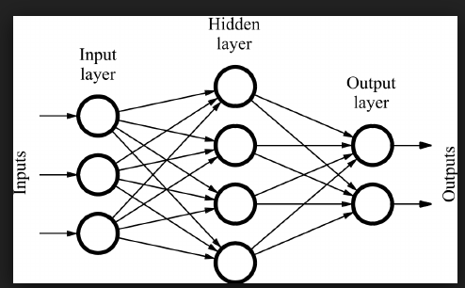

The proposed model is explained as follows:-
The model will take an input data set for analysis. The analysis is done by the type of neural network as explained above. After analysis, the new entry is added in the dataset containing the predicted data. This process can be repeated as many times as the user wants.
The rough sketch of the model is as follows:-
DATA PREDICTION MODEL
INPUT DATASET
MODIFIED DATA SET

From the diagram we can see that input dataset is fed to the model which analyses the input data using neural network. The model then adds the predicted data to the input dataset thereby modifying it.
The proposed model will have the following phases:-
- Input Dataset Pre-processing Phase:-In This phase, the model will read the dataset which has been given by the user.
- Neural Network Creation &Implementation:-In this phase, The model will implement a Neural Network created by the creator of model which will analyse the input dataset and apply a prediction algorithm to generate new entries in dataset containing predicted data.
- New entry addition module:-In this phase, the model will add the new entries generated by the neural network module to the input dataset.
- Output dataset display module :- In this phase, The model will display the modified dataset to the user.

Diagrammatically it can be shown as follows:-

INPUT DATASET PRE-PROCESSING PHASE(PREPROCESSING WORK OF INPUT IS DONE)
NEURAL NETWORK PHASE( A NEURAL NETWORK IS CREATED TO PROCESS AND PREDICT DATA)

NEW ENTRY ADDITION PHASE (NEW ENTRIES ARE INSERTED IN THE GIVEN DATASET)
OUTPUT DATASET DISPLAY PHASE(THE MODIFIED DATASET IS DISPLAYED TO THE USER)

The Basic Structure of Neural Network to be used for Data Prediction Model will have the following characteristics and architecture:-
Characteristics:-
- It will have one Input Layer with N number of input neurons which accept user input data.
- It will have multiple (at least 2) Hidden Layers with N number of neurons to process the input data using activation functions.
- It will have 1 output Layer with N number of output neurons which outputs modified data to the user.

Basic Architecture of Neural Network:-
The Rough Architecture of Neural Network is:-
Input Layer Hidden Layers Output Layer
INPUT WEIGHTS
INPUTS

Outputs

HIDDEN LAYER WEIGHTS

The neural network will have the following characteristics
- One input layer, Two Hidden layers, One output layer.
- Hidden Layers will have 128 neurons each. Output Layer will have 1 neuron.
- Activation Function for Hidden Layers will be Rectified Linear Unit function.
- Activation Function for Output Layer will be Sigmoid Function.

Steps for Stock Market Prediction
Step 1: This step is important for the download data from the net. We are predicting the financial market value of any stock. So that the share value up to the closing date are download from the site.

Step 2: In the next step the data value of any stock that can be converted into the CSV file (Comma Separate Value) so that it will easily load into the algorithm.

Step 3: After selecting the stock dataset file from the folder it will show graph Stock before mapping and stock after mapping.

Step 4: The next step algorithm calculated the log2c and log2g value for minimizing error. So, it will predict the graph for the dataset value efficiently.

Step 5: In final step algorithm display the predicted value graph of select stock which shows the original value and predicted value of the stock.

METHODOLOGIES USED IN THE PREDICTION MODEL
Algorithms used in the model are as follows:-
- Backpropagation Algorithm:- Back propagation is a common method for training a neural network. Back propagation is a method to calculate the gradient of the loss function with respect to the weights in an artificial neural network. It is commonly used as a part of algorithms that optimize the performance of the network by adjusting the weights. Back-propagation, short for "backward propagation of errors," is an algorithm for supervised learning of artificial neural networks using gradient descent.

- Stochastic Gradient Descent:- Gradient Descent is a very popular optimization technique in Machine Learning and Deep Learning and it can be used with most, if not all, of the learning algorithms. It is an iterative technique to train a system through a provided valid data set. In Stochastic Gradient Descent, a few samples are selected randomly instead of the whole data set for each iteration.

COMPARISIONS BETWEEN ALGORITHMS
Stochastic Gradient Descent vs. Batch Gradient Descent:-
In Stochastic Gradient Descent, a few samples are selected randomly instead of the whole data set for each iteration.
In batch gradient descent the “batch” which denotes the total number of samples from a dataset that is used for calculating the gradient for each iteration. The batch is taken to be the whole dataset. Although, using the whole dataset is really useful for getting to the minima in a less noisy or less random manner, but the problem arises when our datasets get really huge.
This problem is solved by Stochastic Gradient Descent. In SGD, it uses only a single sample, i.e., a batch size of one, to perform each iteration. The sample is randomly shuffled and selected for performing the iteration. It has to be done for every iteration until the minima is reached.
In SGD, since only one sample from the dataset is chosen at random for each iteration, the path taken by the algorithm to reach the minima is usually noisier than your typical Gradient Descent algorithm. But that doesn’t matter all that much because the path taken by the algorithm does not matter, as long as we reach the minima and with significantly shorter training time.

Path taken by Batch Gradient Descent Path taken by Stochastic Gradient Descent-
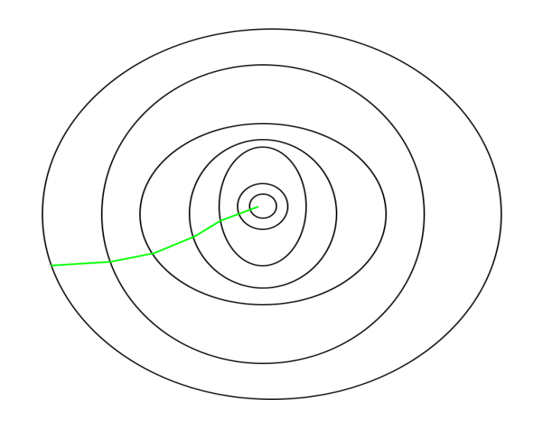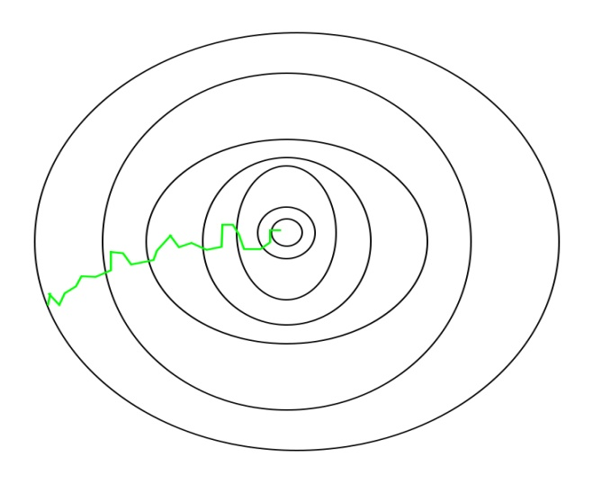

Backpropagation Algorithm:-
It is a supervised learning algorithm used to train a neural network. The steps of the algorithm are explained as follows:-
Steps:-
- Initialize the weights of neural network.
- Perform forward pass by calculating net input and net output at each layer by using the following formulae:
For net input:- (x_{i*}w_{i})+(x_{i+1}*w_{i+1})+b where x is neuron value w is connection weights, b is bias.
For net output:- activation functions are used for calculating net output. types of activation functions are as follows:-
Sigmoid Activation function: It is a activation function of form f(x) = 1 / 1 + exp (-x). Its Range is between 0 and 1.
Hyperbolic Tangent function- Tanh: It’s mathematical formula is f(x) = 1 -exp (-2x) / 1 + exp (-2x). Its range in between -1 to 1.
ReLu- Rectified Linear units: It’s of the form F(x) = max(0,x) i.e. if x < 0 , R(x) = 0 and if x >= 0 , R(x) = x. Here input to these functions is net input.
- Calculate error in forward pass. The error is calculated by the following formula
Net Error = ∑1/2(target-output)².
- Perform backward propagation using the following formula to change values of weights and biases of network
∂(ETotal)/∂(w_{i})=[∂(ETotal)/∂(output of w_{i})]+[∂(output of w_{i})/∂(net output)]+[∂(net output)/∂(w_{i})]
- Update weights using the following formula w_{i}⁺= w_{i}-n(∂(ETotal)/∂(w_{i}). Here n is learning rate, w_{i}⁺ is new weight.
- Steps 1-5 is repeated until error obtained is minimum.

Stochastic-gradient-descent algorithm:-
Stochastic gradient descent also known as incremental gradient descent, is an iterative method for optimizing a differentiable objective function. It is called stochastic because samples are selected randomly (or shuffled) instead of as a single group (as in standard gradient descent) or in the order they appear in the training dataset.
In stochastic (or "on-line") gradient descent, the true gradient of function Q(w) is approximated by a gradient at a single example:
W=W-n∇Q (W).
Here W is function parameter, n is learning rate, ∇Q_{i}(W) is standard derivative of objective function.
As the algorithm traverses through the training set, it performs the above update for each training example. Several iterations can be made over the training dataset until the algorithm converges.
Pseudo code:-
- Choose an initial vector of parameters w and learning rate n .
- Repeat until an approximate minimum is obtained:
- Randomly shuffle examples in the training set.
- For i=1,2,...,m do:
W=W-n∇Q (W).

FLOW CHART
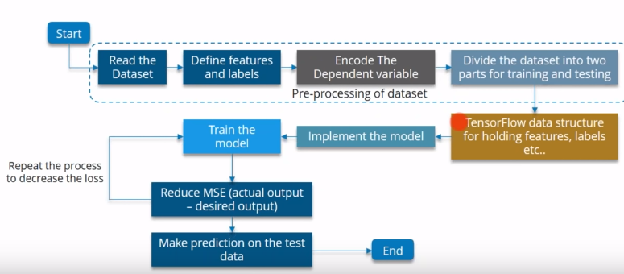

IMPLEMENTATION

Source Code:-

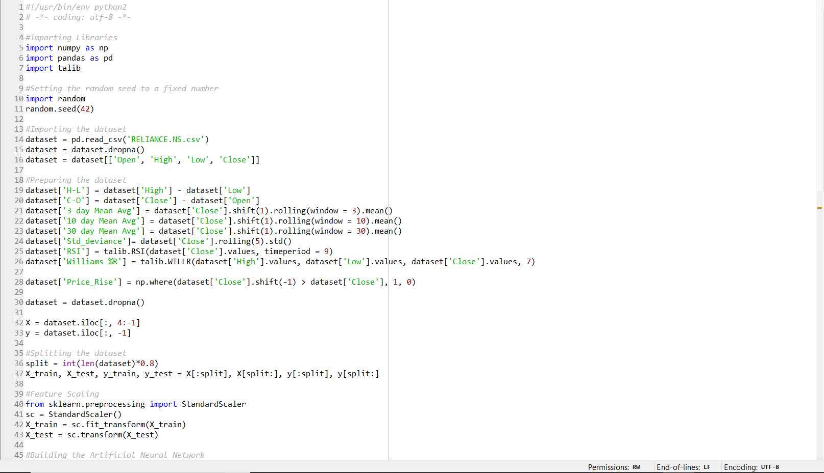

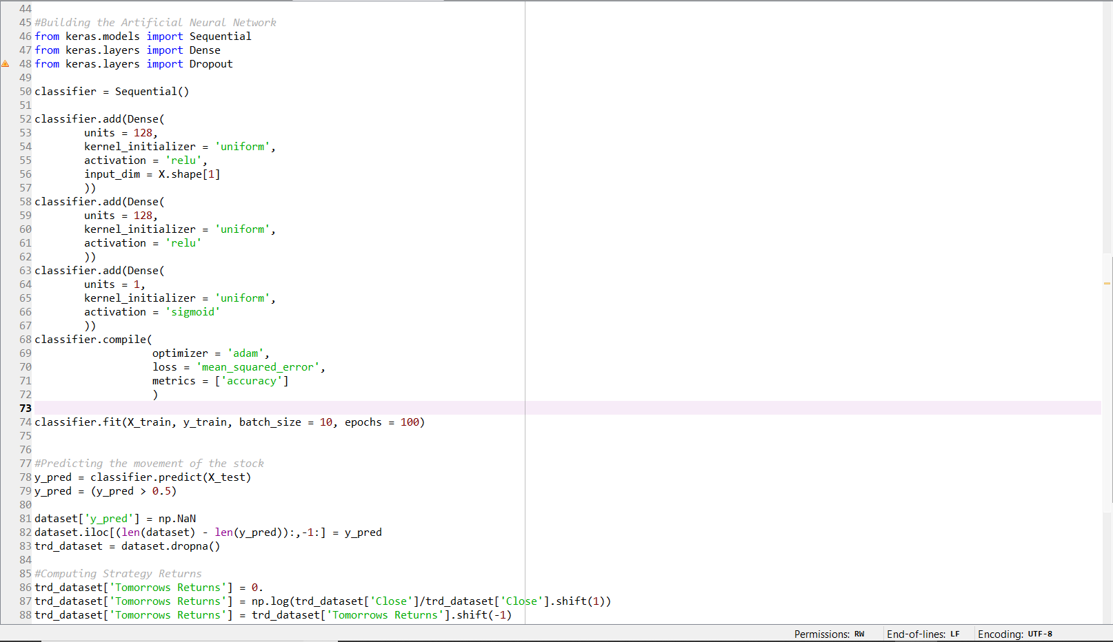

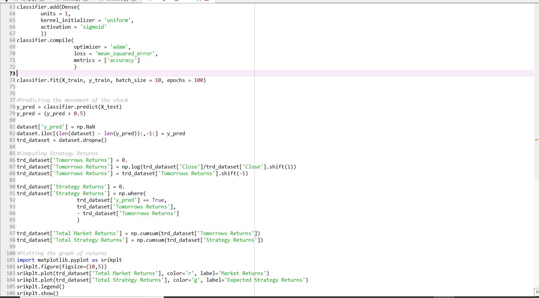

OUTPUT

For dataset RELIANCE.NS

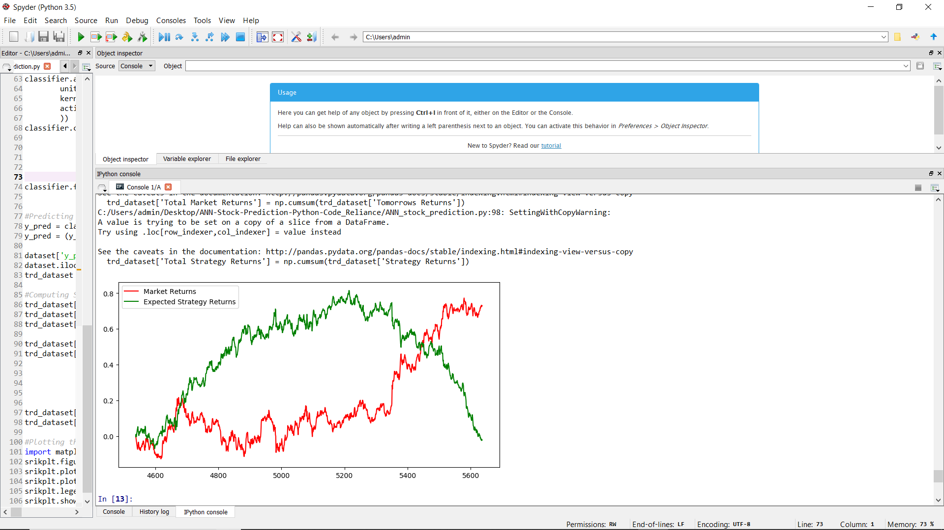

For Data-set TATAMOTORS.NS.-

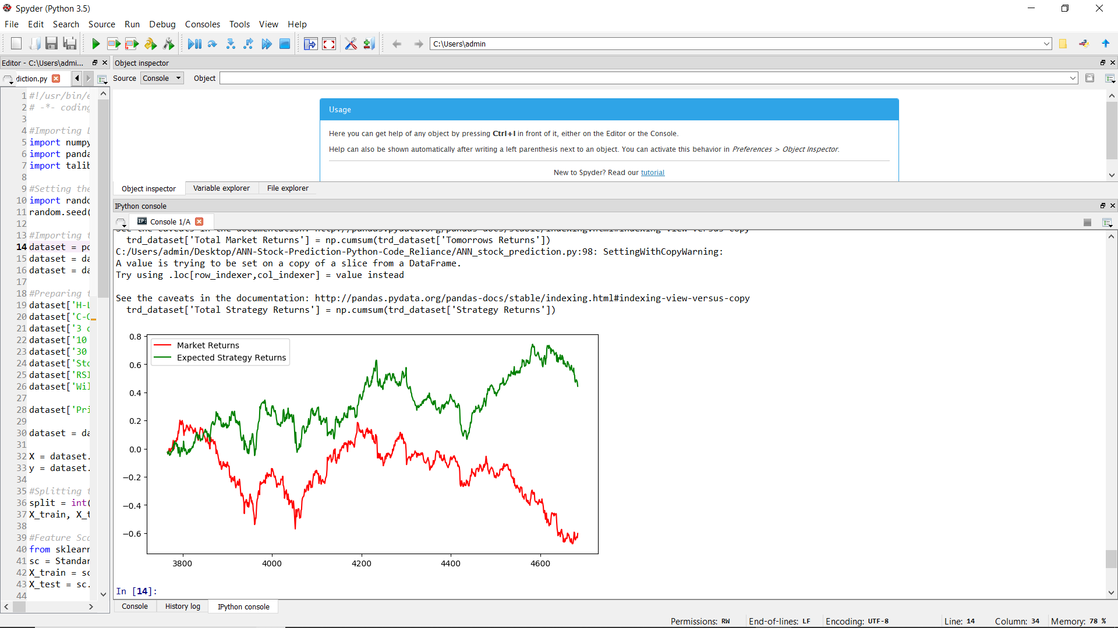

For Dataset NSE-TATAGLOBAL

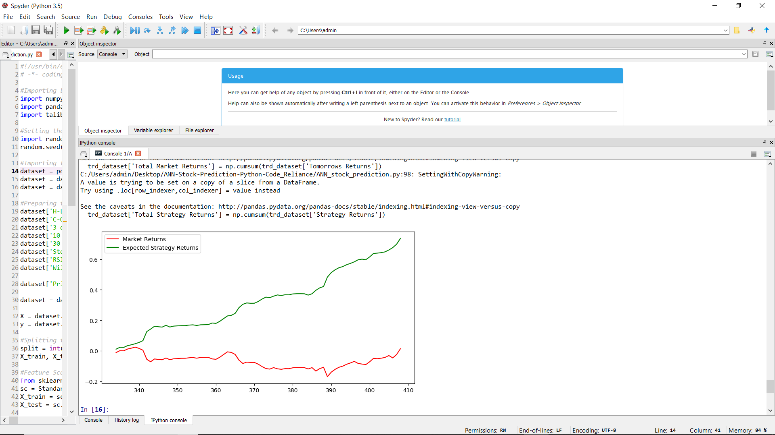

RESULTS AND DISCUSSIONS

We will now plot the market returns and our strategy returns to visualize how our strategy is performing against the market. For this, we will import matplotlib.pyplot. We then use the plot function to plot the graphs of Market Returns and Strategy Returns using the cumulative values stored in the data frame trade dataset. We then create the legend and show the plot using the legend () and show () functions respectively. The plot shown below is the output of the code. The green line represents the returns generated using the strategy and the red line represents the market returns.

CONCLUSIONS AND FUTURE WORKS

We implement the application of Deep Neural Networks to the task of stock!
Market prediction and ANN model and salient feature. Our initial analysis significant correlation between different input parameter.
Now you can build your own Artificial Neural Network in Python and start trading using the power and intelligence of your machines. Apart from Neural Networks, there are many other machine learning models that can be used for trading. The Artificial Neural Network or any other Deep Learning model will be most effective when you have more than 100,000 data points for training the model. This model was developed on daily prices to make you understand how to build the model. It is advisable to use the minute or tick data for training the model, which will give you enough data for an effective training.

- Predicting household energy power from a home smart meter.

- Minute by minute data points predicting 80 steps ahead.

- Predicting S&P500 index.

- Future research can be done with possible improvement such as more refined data and more accurate algorithm.

.

REFERENCES

Reference links and materials are shown below:-
- https://en.wikipedia.org/wiki/Predictive_analytics,"Predictive Analytics"/
- https://www.mathworks.com/discovery/deep-learning.html,"Whatisdeep learning"/
- https://machinelearningmastery.com/inspirational-applications-deep-learning/8 inspirational applications of deep learning/
- https://analyticsindiamag.com/6-types-of-artificial-neural-networks-currently-being-used-in-todays-technology/
- Deep Learning in Predictive Analytics: A Survey Authors:- Vaibhav kumar, M.L Garg
- https://en.wikipedia.org/wiki/Stochastic_gradient_descent
- https://towardsdatascience.com/activation-functions-and-its-types-which-is-better-a9a5310cc8f
- NSE Stock Market Prediction Using Deep-Learning Models-Hiransha Ma , Gopalakrishnan E.Ab , Vijay Krishna Menonab, Soman K.P*
- https://www.edureka.co/blog/backpropagation/

